Trevor Bekolay, 6796723, umbekol0
Assignment 3, Question 3

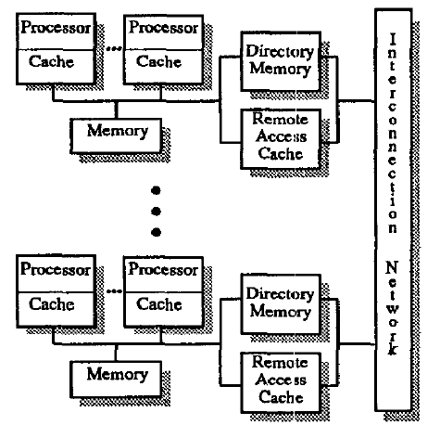
The Stanford DASH multiprocessor is an early implementation of directory based cache coherence in shared memory multiprocessors. Physically, DASH is composed of “clusters” of 4 processors with separate caches and a shared main memory. Within these clusters, bus snooping is used to maintain cache consistency. Each cluster contains a full-mapped directory that details what other processors are caching the lines in the cluster’s main memory. Each cluster also contains a remote access cache (RAC); the RAC serves as an interface between the cluster of processors and the interconnection network. Pending requests for memory in remote clusters are cached in the RAC, and replies are saved in the RAC to be used later by the cluster. The physical design of DASH can be seen in the diagram below, taken from the paper (at http://courses.ece.uiuc.edu/ece511/papers/dash.pdf).
Figure 1 - Physical structure of the DASH multiprocessor

The Directory
The DASH multiprocessor uses a full-mapped directory distributed over the clusters. Each cluster maintains a directory of its own memory. In other words, each cluster maintains a directory containing one entry for each line in main memory. Each directory entry contains one bit to indicate if a remote cluster has a read/write copy of the line, and a bit vector containing one bit for each other cluster to indicate if that cluster has a copy of the line.

Maintaining Cache Coherency
To maintain cache coherency, each processor’s cache uses bus snooping within its cluster to keep its cache coherent. These local caches use the MSI cache coherency protocol.

Each cluster’s bus interfaces with the network through the remote access cache. The DASH protocol uses three primitive operations to ensure cache coherency between clusters: read requests, read-exclusive requests, and writeback requests.

The following terms will be used in the discussion of these primitives:
- Home cluster: The cluster that contains a line in main memory.
- Remote cluster: Any cluster that is not the home cluster.
- Owning cluster: The cluster that has last modified a line.

Read Requests
Read requests begin when a processor executes a load instruction. On a cache miss, the request is sent to main memory. Main memory checks the directory to see if any remote cluster has a dirty copy of the data. If so, the processor requests that data using the RAC. For cache misses on remote data, a request is sent using the RAC to the home cluster, which checks its directory to find the most recently updated version of the line.

Read-exclusive Requests
A read-exclusive request is used to obtain exclusive ownership of a data line so that a processor can write to it. Like read requests, cache coherence operations start when the read-exclusive request propagates down to the local cluster’s bus. A read-exclusive request functions similarly to a read request, in that it uses the directory to locate the most recent copy of the data line, but in addition, it invalidates other currently cached copies.

Writeback Requests
Once a writeback request is loaded onto the RAC, it must be written to the appropriate cluster’s main memory. If the home cluster is the local cluster, it simply updates its main memory. If the home cluster is remote, it sends the writeback request to the home cluster’s RAC.

Advantages of DASH’s Directory-Based Approach
By using a distributed directory based approach, the DASH multiprocessor is able to use a release cache coherency protocol that does not rely on broadcasting. Instead, a cluster can examine its directory to determine what clusters are caching the memory line and send a point-to-point message from the home cluster to the clusters caching the memory line.

